The Relationship Between Seat Inclination Angles and Physical Strain When Using Sloped Stools

Leave blank for blind peer review Author’s Last Name, Author’s First Name*a; Second Author’s Last Name, Second Author’s First Nameb; Third Author’s Last Name, Third Author’s First Nameb (Authors: Calibri 10pt)

a Leave blank for blind peer review Affiliation Organisation Name, City, Country (Affiliation: Calibri 9pt)

b Leave blank for blind peer review Affiliation Organisation Name, City, Country

* Leave blank for blind peer review The corresponding author e-mail address

Prolonged static postures during dental procedures, such as implant surgeries, often lead to significant physical fatigue, especially in the lumbar region of dental professionals. To address this, a dental operating stool (OS) with an adjustable seat tilt was developed and evaluated. The study aimed to determine the optimal seat tilt angle to reduce physical strain and improve work efficiency.

An experiment was conducted with four seat tilt angles: 0°, 3°, 5°, and 7°. Data on physical fatigue and postural stability were collected. Results showed that a 3° tilt significantly reduced physical strain, while a 5° tilt was preferred for usability and task visibility. These findings highlight the importance of seat tilt in reducing fatigue and enhancing operational efficiency. A 3° tilt is recommended for general fatigue reduction, while a 5° tilt is optimal for tasks requiring better visibility and precision during dental procedures.

***Keywords: Dental operating stool (OS); Seat tilt angle; Physical strain;***

1. Research Background

ボートに乗っている男性

AI 生成コンテンツは誤りを含む可能性があります。In recent years, dental procedures such as implant surgeries, which require prolonged periods of maintaining static postures, have increased, leading to significant physical fatigue among dental professionals. Surveys indicate that approximately 70% of dental professionals experience physical pain, with lumbar fatigue being particularly prominent (1). In response to this issue, we have been developing a dental operating stool (OS) equipped with a seat inclination mechanism. However, evidence regarding the effectiveness of seat inclination in reducing physical strain and the optimal inclination angle remains unclear. Figure 1 illustrates the seat inclination of the OS.

*Figure 1. Illustration of OS seat inclination*

1. Research Objectives

The objectives of this study are twofold: (1) to determine the optimal seat inclination angle for the dental operating stool (OS), and (2) to obtain evidence of the effectiveness of seat inclination in reducing physical strain during dental procedures. The inclination angles were set at 3 degrees, 5 degrees, and 7 degrees, and their usability was evaluated. Physical strain was assessed through simulated dental treatment tasks under conditions specified by seat inclination angles and directions, and the effectiveness of strain reduction due to changes in seat inclination angles was verified.

1. Research Methods
   1. **Experimental Equipment**

Table 1 shows the list of sensors used in this study.

*Table 1. List of Sensors*

|  |  |  |
| --- | --- | --- |
| Sensor Name | Manufacturer | Purpose |
| mocopi | Sony | Motion Capture |
| SR Soft Vision | Sumitomo Riko | Pressure Mapping Sensor |

The sensors were selected based on their ability to visualize the degree of lumbar fatigue and their efficiency in installation and analysis, considering their use in clinical experiments targeting dental professionals. Figure 2 shows the sensor attachment positions.

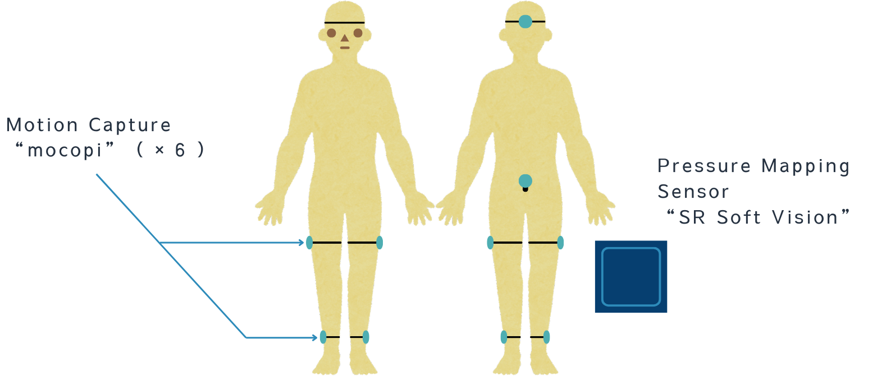

*Figure 2. Sensor attachment positions*

* 1. **Experimental Conditions**

In this experiment, a headrest currently used in dental clinics and a dental experimental head model previously created by the Tanaka Laboratory were utilized to simulate a dental treatment environment. The position of the experimental equipment was set following prior studies, with the height of the headrest set at 850 mm and the angle of the headrest adjusted to 40° (2). Additionally, an experimental OS capable of fixing the inclination angle was created and used for the experiment. The seat height of the experimental OS was set at 520 mm from the floor. Figure 3 shows the experimental OS, and the experimental setup.

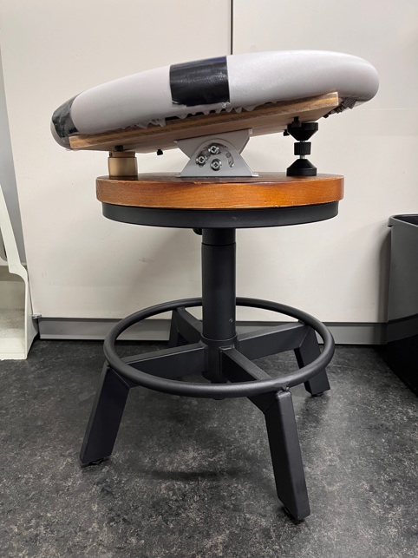机の椅子に座っている男性

AI 生成コンテンツは誤りを含む可能性があります。

*Figure 3. The experimental OS, and the experimental setup.*

* 1. **Experimental Procedure and Patterns**

The participants performed simulated dental treatment tasks. The experiment was conducted a total of nine times: once without any seat inclination, followed by three patterns of inclination directions combined with three patterns of inclination angles. To minimize the influence of order effects on subjective evaluations, the inclination angles were not disclosed to the participants during the experiment.

1. Experimental Results

The experimental results were analysed using data collected during scaling tasks on the "lower anterior teeth to the lower right molars," which were frequently reported as causing high physical strain in the subjective evaluation questionnaire.

* 1. **Motion Capture**

Motion data were analysed by calculating the composite displacement of the rotational angles along the X, Y, and Z axes. The maximum, average, standard deviation, and RMS values of the composite displacement were computed and compared. If the rotational angle displacements along the X, Y, and Z axes are denoted as $∆X$, $∆Y$, and $∆Z$, respectively, the composite displacement $D$,can be calculated using Equation (1).

$$\begin{aligned}D=\sqrt{{\left(ΔX\right)}^{2}+{\left(ΔY\right)}^{2}+{\left(ΔZ\right)}^{2}}\#\left(1\right)\end{aligned}$$

Among these metrics, the RMS value represents the "magnitude of lumbar movement" during the task. Lower RMS values indicate smaller body movements, which can be interpreted as contributing to a reduction in dynamic physical strain. Figure 4 shows an example of the experimental results.

In many datasets, smaller inclination angles were associated with lower RMS values, suggesting that smaller angles may help reduce physical strain.

グラフ

AI 生成コンテンツは誤りを含む可能性があります。*Figure 4. Comparison of Composite Displacement of Lumbar Rotational Angles (During Forward Seat Inclination).*

* 1. **Pressure Mapping Sensor**

Pressure distribution data were analyzed by calculating the composite displacement of the center of pressure movement along the X and Y axes. The maximum, average, standard deviation, and RMS values of the composite displacement were computed and compared. Figure 5 shows an example of the experimental results.

グラフ

AI 生成コンテンツは誤りを含む可能性があります。

*Figure 5. Comparison of Composite Displacement of Center of Pressure Movement (During Forward Seat Inclination).*

However, in some cases, a 5-degree or 7-degree inclination showed favourable effects in reducing physical strain. One possible reason for the variability in data among participants is the differences in how everyone used the OS.

* 1. **Subjective Evaluation**

グラフ, 棒グラフ

AI 生成コンテンツは誤りを含む可能性があります。According to the results of the subjective evaluation questionnaire, most respondents indicated that a 5-degree inclination was the most optimal angle. This was based on a balance of factors such as perceived physical strain, ease of viewing inside the oral cavity, and body stability. Participants were asked to rank the angles based on their overall usability and suitability for dental procedures. Points were assigned using a scoring system: 3 points for the top-ranked angle, 2 points for the second, and 1 point for the third. Figure 6 shows the aggregated results.

*Figure 7. Survey Results for Optimal Inclination Angles of the OS.*

1. **Conclusion and Discussion**

From the results obtained in this study, it was concluded that the optimal inclination angle for the OS is 3 degrees from the perspective of reducing physical strain and 5 degrees from the perspective of usability. In dental treatment settings, it is considered appropriate to set the inclination angle to 5 degrees, particularly during tasks that require leaning forward, and to adjust it to 3 degrees during other tasks. This approach can help reduce the overall physical burden during treatment.

1. Prospects

In this study, experiments involving students were conducted to investigate the relationship between inclination angles and their effects on reducing physical strain. Moving forward, further validation of the OS’s utility will be pursued through experiments using the prototype OS and by analysing a larger dataset. Additionally, as the experimental methods were reviewed during the data analysis process, these improvements will be applied to future research.

1. **References**

1) 小林大輔,歯科医療従事者を対象とした座面傾斜型スツールの使用評価,pp.4-8,芝浦工業大学,卒業論文,2023.

2) 山田航大,歯科医療従事者の診療中の姿勢に関する研究,pp.1-49,芝浦工業大学,修士論文,2019.

**Images**

Images and figures should have a resolution that supports print and online viewing. We recommend a resolution of 300 ppi and a minimum resolution of 150 ppi. Always place images/figures within the main text body and apply the ‘IASDR Caption’ style to the captions. Images/figures and captions should always align to the left margin and never exceed the column width. Number images/figures sequentially, starting with Figure 1. See Figure 1 for an example.

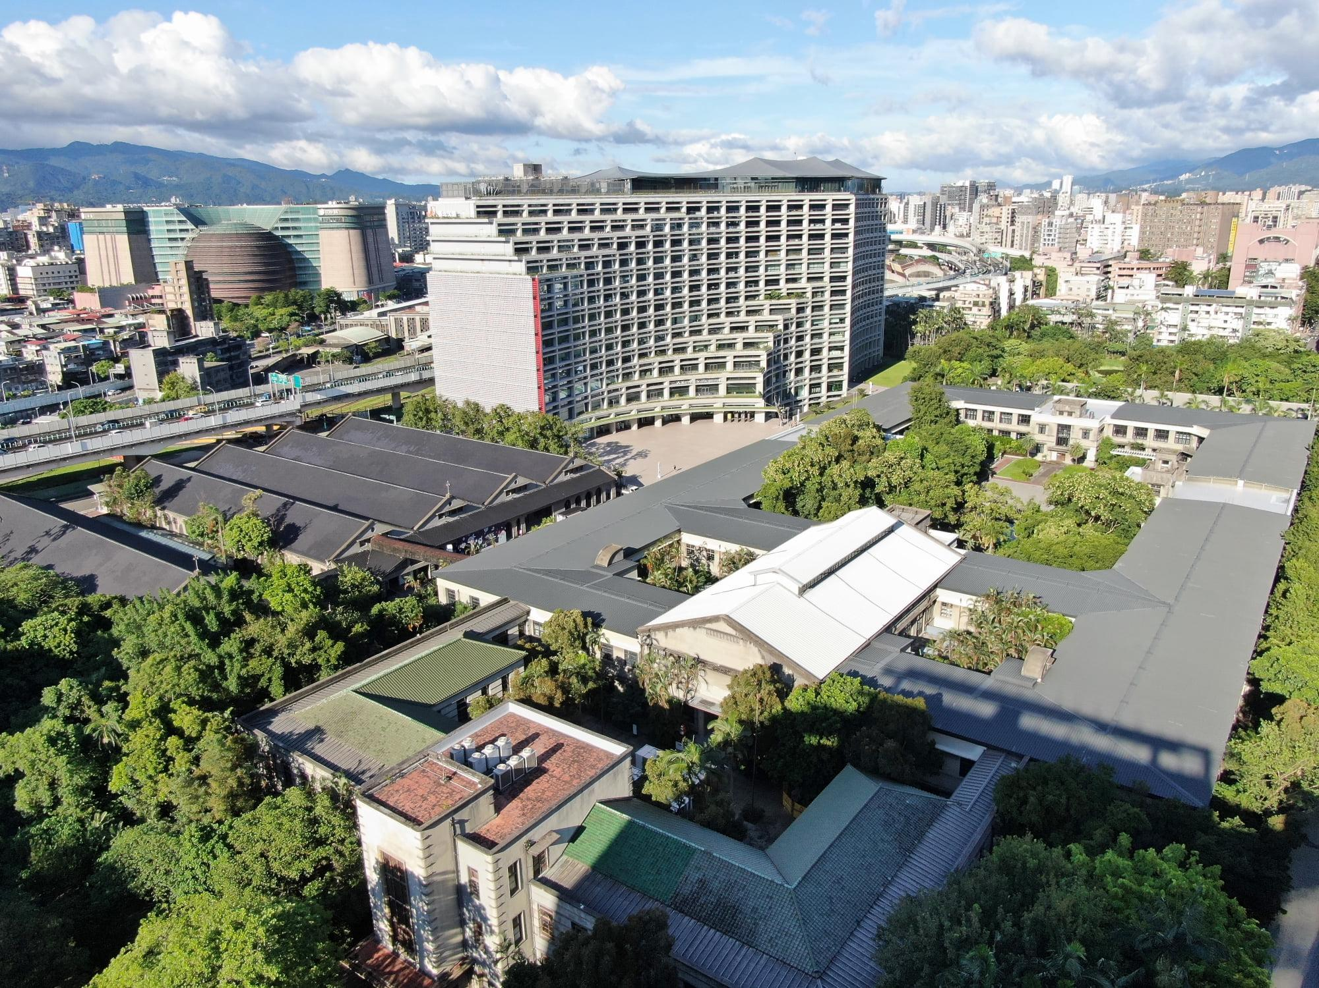

*Figure 1. Songshan Cultural and Creative Park. Source: TDRI. (Caption: Calibri italic 9pt)*

Captions for the figures should clearly explain what the image illustrates concerning the text. If there are two or more images side-by-side, as shown in Figure 2, you should combine the figures into a single image using image editing software (e.g., Adobe Photoshop) before placing them in the text.

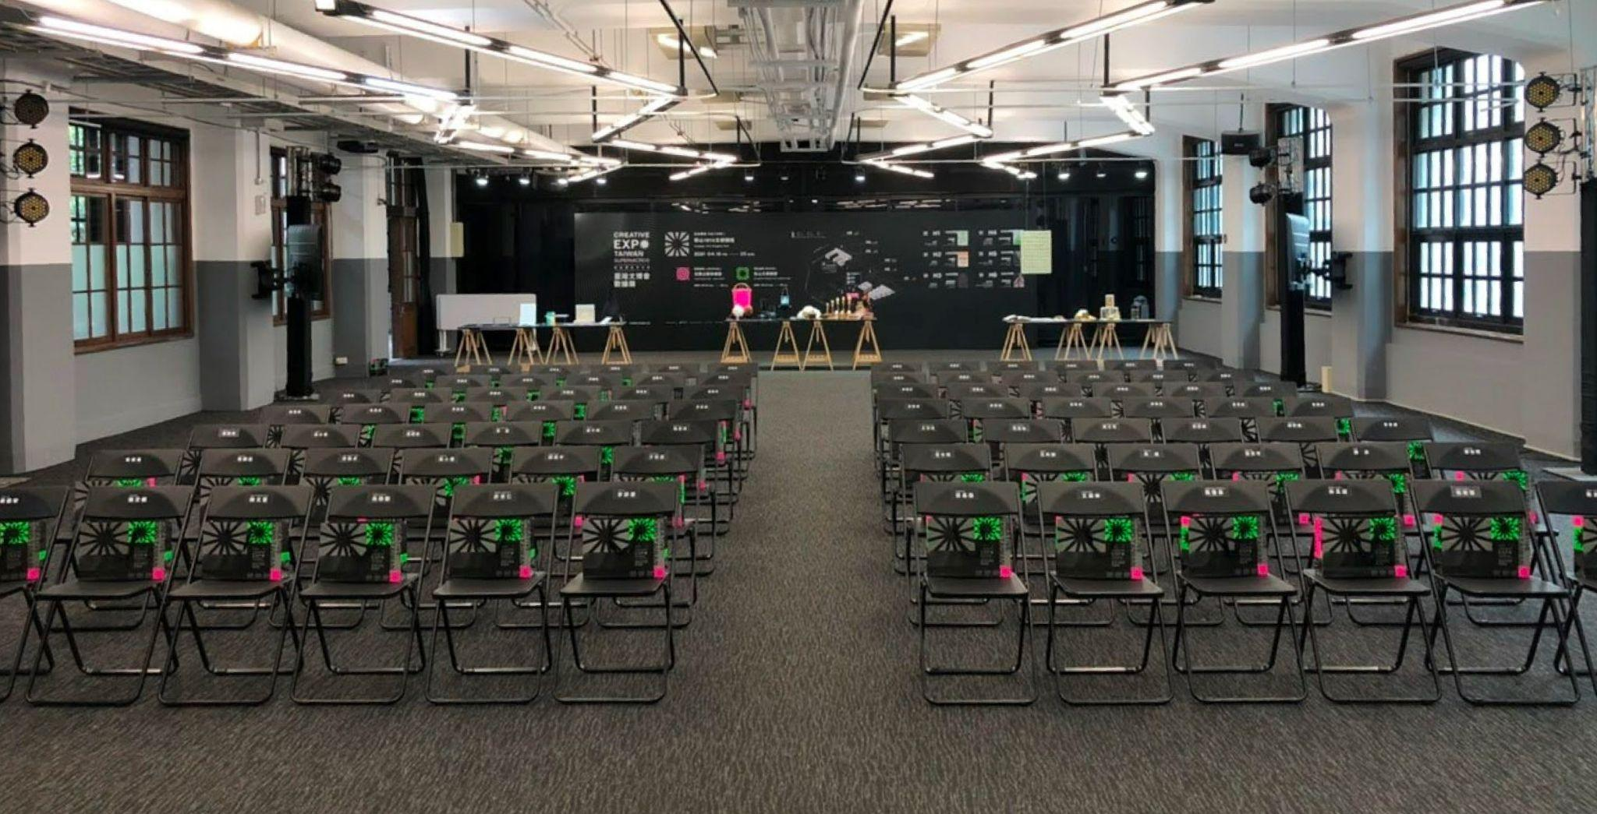

*Figure 2. Shared workspaces at TDRI office. Source: TDRI.*

We welcome authors to use colour images.

* 1. **Lists**

For sequential listings with numbers, use the ‘IASDR Numbered List’ style. For example:

1. List item 1 (Numbered list: Calibri 11pt)
2. List item 2
3. List item 3

For non-sequential listings in bullet points, use the ‘IASDR Bullet List’ style. For example:

* Bullet point 1 (Bullet list: Calibri 11pt)
* Bullet point 2
* Bullet point 3
  1. **Tables**

Use Word’s table feature to create tables and format them as Table 1. If possible, left-align the text of all columns. Number tables sequentially, starting with Table 1.

See Table 1 for an example.

|  |  |  |  |
| --- | --- | --- | --- |
| (Table text: Calibri 10pt) | **Column 2** | **Column 3** | **Column 4** |
| **Second Row** | Cell one | Cell four | Cell seven |
| **Third Row** | Cell two | Cell five | Cell eight |
| **Fourth Row** | Cell three | Cell six | Cell nine |

*Table 1. This is an example of a table that adapts from an external source*

If the table is from an external source, indicate the original reference below the table using ‘IADSR Caption’; if the table presents an original work, please insert one empty line below the table by using ‘IASDR Caption’, as shown in Table 2.

*Table 2. This is an example of the formatting of an original table (Table title: Calibri 10pt)*

|  |  |  |  |
| --- | --- | --- | --- |
| (Table text: Calibri 10pt) | **Column 2** | **Column 3** | **Column 4** |
| **Second Row** | Cell one | Cell four | Cell seven |
| **Third Row** | Cell two | Cell five | Cell eight |
| **Fourth Row** | Cell three | Cell six | Cell nine |

* 1. **Referencing**

Author(s) should follow the **APA** reference style for the papers. For more details, please refer to lessons 16-19 of “[Basics of Seventh Edition APA Style](https://extras.apa.org/apastyle/basics-7e/#/).” To format the reference list, use the ‘IASDR Reference’ style. Where possible, include DOI.

Place citations that do not form part of a sentence inside parenthesis. **For example:** (Jackson, 2019). Show the author(s) name in text and the year within parenthesis for citations that are part of a sentence. **For example:** Jackson (2019) argues that…

When citing multiple works by the same author(s), separate the publication years with commas. When citing works by different authors in one parenthesis, separate them by semicolons and place them in alphabetical order. **For example:** (Dillard, 2020; Jackson, 2019).

Give both names when a reference is authored by one or two individuals. **For example:** (Kushilevitz & Malkin, 2016). For three or more authors, name only the first one followed by et al.. **For example:** (Duckworth et al., 2019).

**Acknowledgements**

You can use this optional section to acknowledge the support you have had for your research from internal and external funding bodies, participants, colleagues, and others. You have a maximum limit of 100 words. Please leave blank for the anonymous submission.

**References**

Examples of references (taken from [APA Style](https://apastyle.apa.org/style-grammar-guidelines/references/examples)):

Journal article with a DOI:

Grady, J. S., Her, M., Moreno, G., Perez, C., & Yelinek, J. (2019). Emotions in storybooks: A comparison of storybooks that represent ethnic and racial groups in the United States. *Psychology of Popular Media Culture, 8*(3), 207–217. https://doi.org/10.1037/ppm0000185 (Reference list: Calibri 10pt)

Conference proceedings published in a journal:

Duckworth, A. L., Quirk, A., Gallop, R., Hoyle, R. H., Kelly, D. R., & Matthews, M. D. (2019). Cognitive and noncognitive predictors of success. Proceedings of the National Academy of Sciences, USA, 116(47), 23499–23504. https://doi.org/10.1073/pnas.1910510116

Conference proceedings published as a whole book:

Kushilevitz, E., & Malkin, T. (Eds.). (2016). *Lecture notes in computer science: Vol. 9562. Theory of cryptography.* Springer. https://doi.org/10.1007/978-3-662-49096-9

Conference proceedings published as a book chapter:

Bedenel, A.-L., Jourdan, L., & Biernacki, C. (2019). Probability estimation by an adapted genetic algorithm in web insurance. In R. Battiti, M. Brunato, I. Kotsireas, & P. Pardalos (Eds.), *Lecture notes in computer science: Vol. 11353. Learning and intelligent optimization* (pp. 225–240). Springer. https://doi.org/10.1007/978-3-030-05348-2_21

Book:

Jackson, L. M. (2019). *The psychology of prejudice: From attitudes to social action* (2nd ed.). American Psychological Association. https://doi.org/10.1037/0000168-000

Sapolsky, R. M. (2017). *Behave: The biology of humans at our best and worst*. Penguin Books.

Svendsen, S., & Løber, L. (2020). *The big picture/Academic writing: The one-hour guide* (3rd digital ed.). Hans Reitzel Forlag. https://thebigpicture-academicwriting.digi.hansreitzel.dk/

Chapter in a book:

Aron, L., Botella, M., & Lubart, T. (2019). Culinary arts: Talent and their development. In R. F. Subotnik, P. Olszewski-Kubilius, & F. C. Worrell (Eds.), *The psychology of high performance: Developing human potential into domain-specific talent* (pp. 345–359). American Psychological Association. https://doi.org/10.1037/0000120-016

Dillard, J. P. (2020). Currents in the study of persuasion. In M. B. Oliver, A. A. Raney, & J. Bryant (Eds.), *Media effects: Advances in theory and research* (4th ed., pp. 115–129). Routledge.

Thestrup, K. (2010). To transform, to communicate, to play—The experimenting community in action. In E. Hygum & P. M. Pedersen (Eds.), *Early childhood education: Values and practices in Denmark*. Hans Reitzels Forlag. https://earlychildhoodeducation.digi.hansreitzel.dk/?id=192